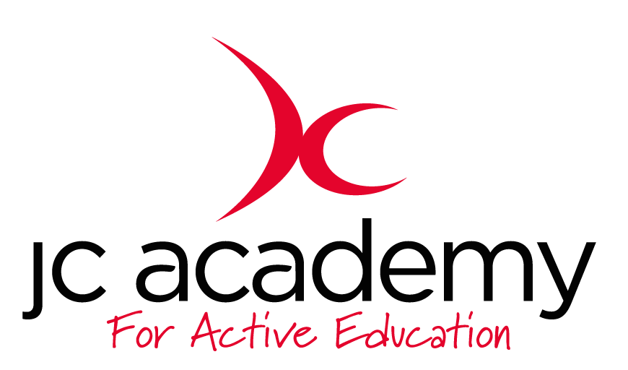

Class: Year 6 (Week 3)
Lesson: Hockey
Lesson Objective:
Understanding the game of Hockey including rules, regulations and skill components

Resources Hockey Sticks/Tennis Ball/Cones/Discs

Warm Up:

Children will be asked to move around the hall using all the skill components that we have worked on such as Agility, Balance, Co-ordination and reactions. These will include Jumping/Hopping/Skipping.

Coaching Points:
Agility
Balance
Co-ordination
Reaction Skills

Safety Points:
Awareness
Good Behaviour
Awareness of surroundings

Main Activity: (Including teaching/Coaching Points/Include any diagrams)

- All children will now be put into pairs
- They will have a go at moving with the ball
- For now, it will just straight lines from one end to the other
- Then there will be cones placed in and around the hall, in the pairs they will now move around the hall moving through all the different gates

Coaching points:

- Technique
- Movement with the ball
- Hand to stick co-ordination
- Balance

Safety Points:
Awareness
Good Behaviour
Awareness of surroundings

Warm Down:
Gentle Jogging
Understanding the importance of a warm down
Question time with Mr Jarvis

Coaching Points:
Breathing Techniques
Slowing the heart rate down

Safety Points:
Awareness
Good behaviour
Awareness of surroundings

Plenary:

RED:
Break down session such as passing routines

AMBER:
All children adequate at movement

GREEN:
Adjust session to suit

