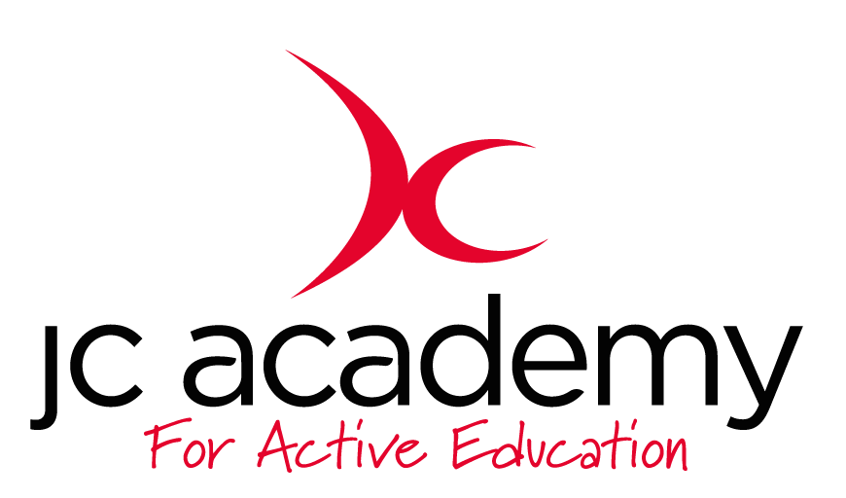

Class: Year 5
Lesson: Hockey
Lesson Objective:
Understanding the game of Hockey including rules, regulations and skill components

Resources Hockey Sticks/Tennis Ball/Cones/Discs

Warm Up:

Children will be asked to move around the hall using all the skill components that we have worked on such as Agility, Balance, Co-ordination and reactions. These will include Jumping/Hopping/Skipping.

Coaching Points:
Agility
Balance
Co-ordination
Reaction Skills

Safety Points:
Awareness
Good Behaviour
Awareness of surroundings

Main Activity: (Including teaching/Coaching Points/Include any diagrams)

- All children will be put into groups of 4
- They will have a hockey stick each
- Before we get the ball the groups will learn the correct grip for holding a hockey stick and they will begin to move around the hall. Ensuring the safety points have been covered.
- Each group will then get a ball (Tennis ball to begin with) then start working on ball manipulation (Where to make good contact of the ball/When to take big strokes and small strokes

Coaching points:

Safety Points:
Awareness
Good Behaviour
Awareness of surroundings

Warm Down:
Gentle Jogging
Understanding the importance of a warm down
Question time with Mr Jarvis

Coaching Points:
Breathing Techniques
Slowing the heart rate down

Safety Points:
Awareness
Good behaviour
Awareness of surroundings

Plenary:

RED:
Break down session such as passing routines

AMBER:
All children adequate at movement

GREEN:
Adjust session to suit

