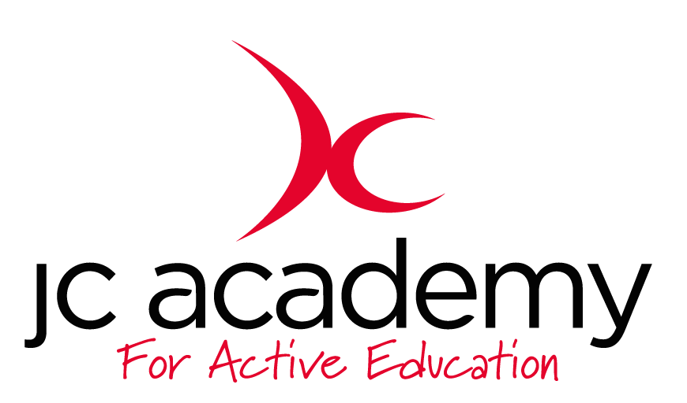

Class: Y2
Lesson: Hockey
Lesson Objective:
TO PASS CORRECTLY USING A HOCKEY STICK

Resources:
HOCKEY STICKS, CONES, TENNIS BALLS

Warm Up:
JOGGING AOUND THE AREA, SKIPPING, JUMPING, SIDE STEPS ON THE COACHES COMMAND. DYNAMIC STRECHES WILL FOLLOW.

Coaching Points:

Safety Points:
BE AWARE OF WHOS AROUND
Main Activity: (Including teaching/Coaching Points/Include any diagrams)

CHILDREN WILL LINE UP IN 3S. THEY WILL TAKE IT IN TURNS TO PASS THE BALL TO THE PERSON OPPOSITE THEM, THEY WILL CONTROL THE BALL AND PASS IT BACK TO THE NEXT PERSON. ONCE THEY’VE HAD A GO, THEY WILL GO TO THE BACK OF THE LINE. NEXT, THEY WILL NEED TO USE THEIR ACCURACY TO PASS THE BALL THROUGH CONES TO THE PERSON OPPOSITE THEM. LASTLY THEYB WILL NEED TO CONTROL THE BALL IN TO SPACE BEFORE PASSING BACK TO A TEAM MATE.

Coaching points:
RIGHT HAND BOTTOM OF THE GRIP, LEFT HAND TOP OF THE GRIP, HOCKEY STICK ACROSS THE BODY, BENT BACK, GLIDE THE HOCKEY STICK ACORSS THE FLOOR TO PASS.
Safety Points:
BE AWARE, NO SWIGING THE STICKS, KEEP THE STICKS LOW.
Warm Down:
JOGGING, WALKING, FOLLOWED BY STATIC STRECHES.

Coaching Points:

Safety Points:
BE AWARE OF WHOS AROUND
Plenary:

RED:
DECREASE THE DISTANCE
AMBER:
STANDARD SESSION

GREEN:
INCREASE THE DISTANCE

