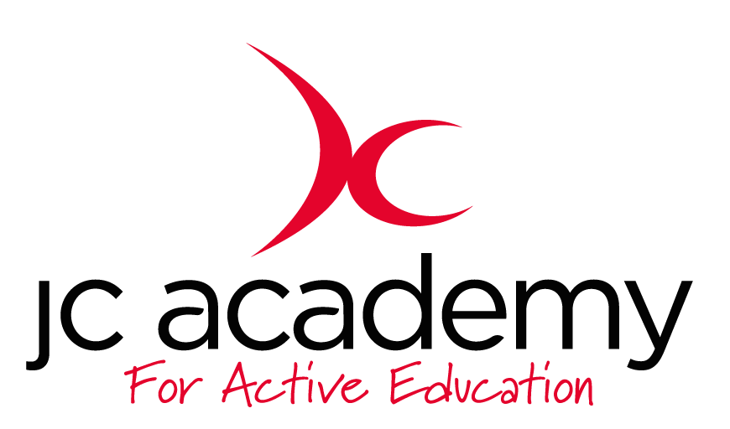

Class: year 3
Lesson: basketball week 2: Passing
Lesson Objective:
To be able to understand and apply knowledge of a range of different passes which can be used within the sport of basketball.
Resources:
basketballs x15
Cones x10 of each colour
Bibs x15

Warm Up:
Coach lead warm up: students will follow a range of movement which have been commanded by the lead. Both static and dynamic stretching will be used during this time. Students will be asked for input towards different movements/stretches throughout.
Coaching Points:
Speaking/listening skills (communication)
Increase HR and stretching out muscles (Prepare body for exercise)

Safety Points:
- Spacial awareness between each student
- Environment checked (risk assessment)
- Equipment checked before and throughout session.
Main Activity: (Including teaching/Coaching Points/Include any diagrams)
Recap of last week’s lesson, what it entailed and what was learnt (demos possible). Then Explain about different forms of passing which can be done within the sport of basketball. Starting with basics, then progressing dependent on ability and attitudes.

- Demonstration/recap of how to perform a basic chest pass again to reinsure understanding, then show a bounce pass.

- Uncontested: Working in group standing still, give them a chance to familiarise themselves with a chest pass again, working on improving the technique. Then will lead onto trying the bounce pass. Both of these will include section where they will work against the clock to get as many passes done as possible. Working heavily abC’s (co-ordination: hand/eye)
- Recap everything done so far with Q/A

- Contested: Leading on to ball control on the move, introduction of gates on the floor, in which a person must receive a pass correctly (using two hands) to gain a point..

- Game related: small sized matches with end zones as goals to give them a chance to work on everything they have learnt/recapped in the session.

Recaps of each part of the session and also ABC’s throughout.
Coaching points:
- Position of hands
- Chest pass (ball in front of chest and push away)
- Bounce pass (pushing into ground with some force so it bounce in front of partner).

Safety Points:
- Spacial awareness between each student
- Environment checked (risk assessment)
- Equipment checked before and throughout session.
Warm Down:
Coach lead cool down: coach lead the group in different movements from fast to slow while bring in static stretches.

Coaching Points:
Lower HR (relaxing body)
Reduce lactic acid from muscles (cramp removed)
Help bring them down to a rest to prepare for remaining lessons.
Safety Points:
- Spacial awareness between each student
- Environment checked (risk assessment)
- Equipment checked before and throughout session.
Plenary:
They have worked on basic ball handling skills, leading into passing this week. Adjusting techniques, trying to improve chances of success and quality of play.

RED: they are able to complete basic passing in basketball as long as they are aided with constant help especially 121’s. Otherwise completing tasks would be difficult and could take a whole lesson.

AMBER: they should be able to work through each section of the session without much help or assistance and have a competent understanding of passing within basketball but may struggle to apply the knowledge effectively with the game related.

GREEN: they should be able to excel at each part of the session, they can use knowledge effectively within a game situation and may be useful to help the lower abilities (red) to progress into the next level.

