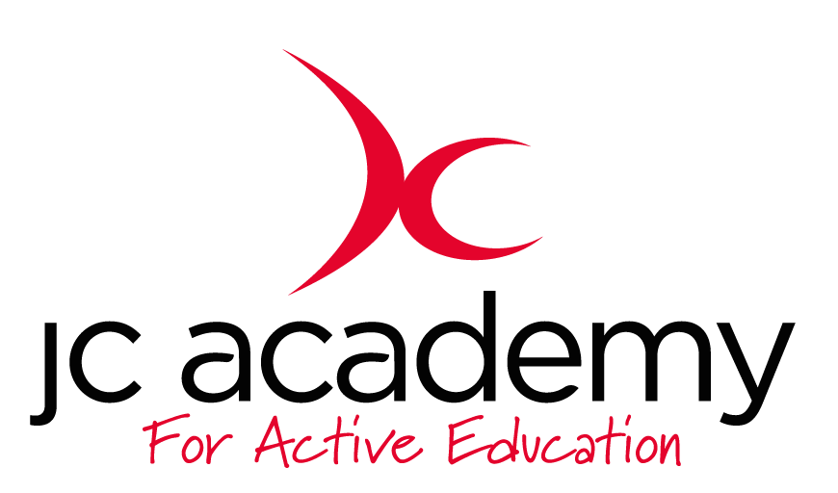

Class: 1.3
Lesson: Athletics
Lesson Objective:

To understand what is involved in Athletics working on different techniques and tasks.

First week will be focusing on running and running technique

Resources:

- Cones
- Discs

Warm Up:

All children will move freely around the area in the hall. The children will be working on their Agility, Balance and Co-ordination. They will be encouraged to concentrate on all fundamental movements such as moving forwards/Backwards and side to side.

Safety Points:

- Listening Skills
- Communication
- Fluid risk assessment carried out before each session

Main Activity: (Including teaching/Coaching Points/Include any diagrams)

Hurdles

Children will now work on the hurdling while moving at pace. The children will now begin to learn how to jump and move across the hurdles. They will be expected to start slowly and begin to pick up the pace. The children will be shown the correct technique to move over the hurdles. They will be learning the ‘open the gate and closing the gate technique’ this will help the children break down what is expected of them. They will take the first step over before the trailing leg also comes over the hurdle. Again, once completed they will make their way to cone before using the correct turning technique.

Safety Points:
- Teamwork
- Communication
- Awareness

Warm Down:

- Breathing techniques
- Slow movement around the hall

Safety Points:

- Listening Skills
- Communication
- Teamwork
- Risk Assessment carried out at all times

Plenary:

Children understand more about running techniques and will be questioned at the end of every lesson

RED:

Break down of the lesson if children are struggling with lesson input- especially with a certain technique or movement.

AMBER:

Show differentiation should some children still be struggling with the lesson. Challenge children to try at least one of the techniques.

GREEN:

Move the lesson on further with more technical input and different technique variations.

