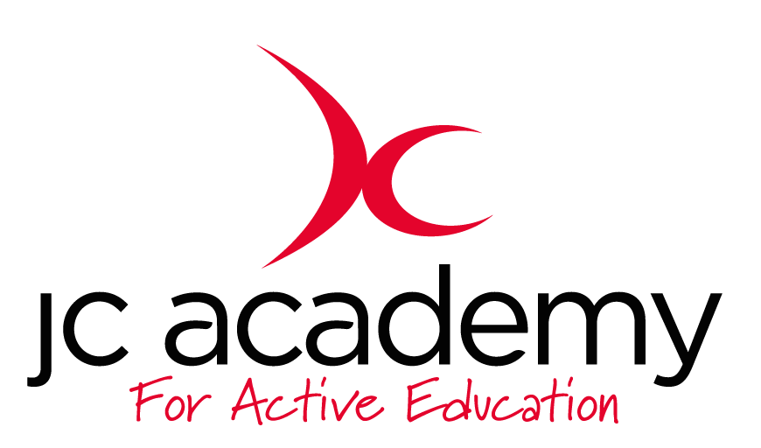

Class: 1.3
Lesson: Athletics
Lesson Objective:

To understand what is involved in Athletics working on different techniques and tasks.

First week will be focusing on running and running technique

Resources:

- Cones
- Discs

Warm Up:

All children will move freely around the area in the hall. The children will be working on their Agility, Balance and Co-ordination. They will be encouraged to concentrate on all fundamental movements such as moving forwards/Backwards and side to side.

Safety Points:

- Listening Skills
- Communication
- Fluid risk assessment carried out before each session

Main Activity: (Including teaching/Coaching Points/Include any diagrams)

Children will be learning the correct movement and running technique. They will be placed in groups of 5 or 6 dependent on size of the group. The coach will then place discs at the other end of the hall where the children will run too. The coach will then talk to the children about leg to arm ratio and how to run in tandem. They will run to the other end and make their way back to their group.

Safety Points:
- Teamwork
- Communication
- Awareness

Warm Down:

- Breathing techniques
- Slow movement around the hall

Safety Points:

- Listening Skills
- Communication
- Teamwork
- Risk Assessment carried out at all times

Plenary:

Children understand more about running techniques and will be questioned at the end of every lesson

RED:

Break down of the lesson if children are struggling with lesson input- especially with a certain technique or movement.

AMBER:

Show differentiation should some children still be struggling with the lesson. Challenge children to try at least one of the techniques.

GREEN:

Move the lesson on further with more technical input and different technique variations.

