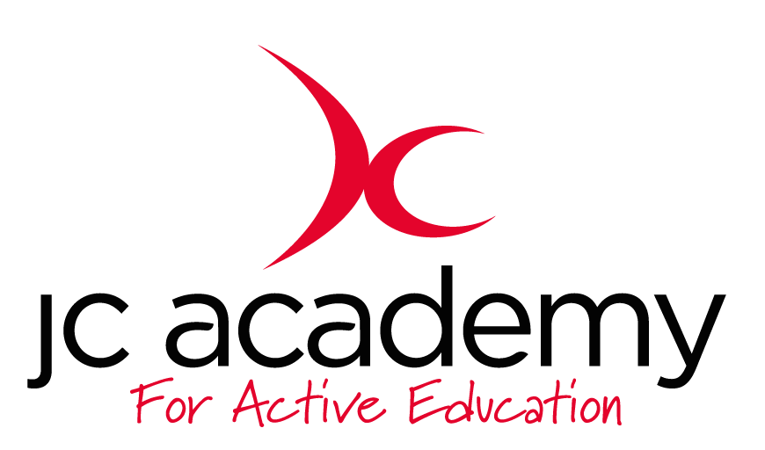

Class: Elmwood
Lesson: Games 1
Lesson Objective:

Working on Balance and movement
Resource
Cones, Bibs, Sponge Ball.

Warm Up:

Kids get into a circle with 1 ball aim is not to have the ball when the whistle in blown, last child standing wins

Coaching Points:

Soft hands

Eyes focusing on the ball

Balance

Safety Points:

- Make sure area is completely risk free of any spills, equipment etc.

Main Activity: (Including teaching/Coaching Points/Include any diagrams)
One player (X) leads, the other (Y) copies. The lead player has to touch the cone to the left or right before the copier (mirror) gets there by trying to outwit their opponent using a fake once the cone is touched that player gets the point

Coaching points:

Balance

Speed

Agility

Safety Points:

- Make sure area is completely risk free of any spills, equipment etc.

Warm Down:

Kids warm down by stretching

Coaching Points:

- Support and develop the ideas children create.

Safety Points:

- Make sure area is completely risk free of any spills, equipment etc.

Plenary:

RED:

AMBER:

GREEN:

