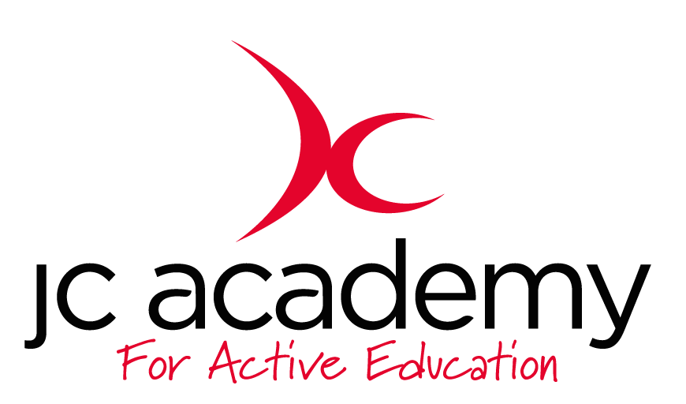

Class: 1.3
Lesson: Athletics
Lesson Objective:

To understand what is involved in Athletics working on different techniques and tasks.

First week will be focusing on running and running technique

Resources:

- Cones
- Discs

Warm Up:

All children will move freely around the area in the hall. The children will be working on their Agility, Balance and Co-ordination. They will be encouraged to concentrate on all fundamental movements such as moving forwards/Backwards and side to side.

Safety Points:

- Listening Skills
- Communication
- Fluid risk assessment carried out before each session

Main Activity: (Including teaching/Coaching Points/Include any diagrams)

Hurdles & Running Technique

The coach will, now assess the children, by being put into teams. They will now cover everything so far this term. Including running technique and hurdle technique.

Safety Points:
- Teamwork
- Communication
- Awareness

Warm Down:

- Breathing techniques
- Slow movement around the hall

Safety Points:

- Listening Skills
- Communication
- Teamwork
- Risk Assessment carried out at all times

Plenary:

Children understand more about running techniques and will be questioned at the end of every lesson

RED:

Break down of the lesson if children are struggling with lesson input- especially with a certain technique or movement.

AMBER:

Show differentiation should some children still be struggling with the lesson. Challenge children to try at least one of the techniques.

GREEN:

Move the lesson on further with more technical input and different technique variations.

