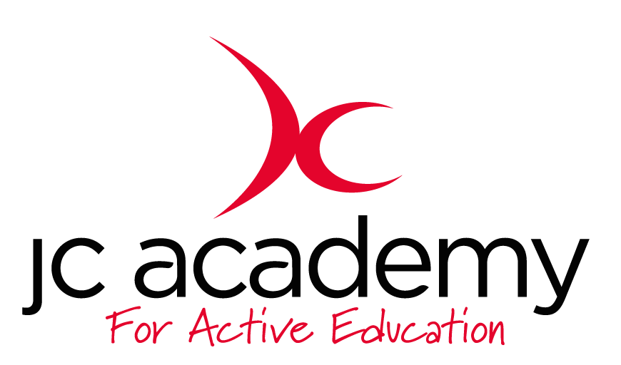

Class: 1.3
Lesson: Athletics
Lesson Objective:

To understand what is involved in Athletics working on different techniques and tasks.

First week will be focusing on running and running technique

Resources:

- Cones
- Discs

Warm Up:

All children will move freely around the area in the hall. The children will be working on their Agility, Balance and Co-ordination. They will be encouraged to concentrate on all fundamental movements such as moving forwards/Backwards and side to side.

Safety Points:

- Listening Skills
- Communication
- Fluid risk assessment carried out before each session

Main Activity: (Including teaching/Coaching Points/Include any diagrams)

Children will be continuing to work on their running technique however they will now be working on how to turn and change direction quickly. The children will continue to work on their leg to arm ratio, however, they will now work on turning and running in a different direction. The children will now not be expected to go around the cone, but turn quickly using the correct leg and arm movement. When the children reach their teammate they have to high five the next in line. The coach will be looking for body position and fluid movement.

Safety Points:
- Teamwork
- Communication
- Awareness

Warm Down:

- Breathing techniques
- Slow movement around the hall

Safety Points:

- Listening Skills
- Communication
- Teamwork
- Risk Assessment carried out at all times

Plenary:

Children understand more about running techniques and will be questioned at the end of every lesson

RED:

Break down of the lesson if children are struggling with lesson input- especially with a certain technique or movement.

AMBER:

Show differentiation should some children still be struggling with the lesson. Challenge children to try at least one of the techniques.

GREEN:

Move the lesson on further with more technical input and different technique variations.

